# A

## PROJECT REPORT

ON

### TALENT HUNT

Submitted in partial fulfillment for the award of

**Post Graduate Diploma in Advance Computing**

# (PG-DAC) from

### INSTITUTE OF EMERGING TECHNOLOGIES

**Authorized Training Centre**



### Under the Guidance of Mr. Rahul Bihani BY

**Name of student/s and PRN**

| **1. SUYOG SHEJUL** | **230345920103** |
| --- | --- |
| **2. TANMAY SHIMPI** | **230345920105** |
| **3. TARUN KUMAR** | **230345920106** |
| **4. HARSHALA WADEKAR** | **230345920037** |
|  |  |



# CERTIFICATE

This is to certify that the project report entitled **Talent Hunt** is a bonfire work carried out by

**1. Suyog Shejul, 2. Tanmay Shimpi, 3. Tarun Kumar, 4. Harshala Wadekar** submitted in partial fulfillment of the requirement for the C-DAC ACTS, DAC course in the Institute of Emerging Technology in the batch of March 2023.

**Course Coordinator External Examiner**

**ACKNOWLEDGEMENT**

This project **Talent Hunt** was a great learning experience for us and we are submitting this work to Advanced Computing Training School (CDAC).

We are very glad to mention **Mr. Rahul Bihani** for his valuable guidance to work on this project. His guidance and support helped us to overcome various obstacles and intricacies during the course of project work.

Our most heart full thanks goes to ***Mr. Sangram Patil* (Director ,IET)**who gave all the required support and kind coordination to provide all the necessities like required hardware , internet facility and extra lab hours to complete the project and throughout the course up to the last day here in C-DAC ACTS, Pune.

Sign of student

### Name of Student

| **Sr.No.** | **Name** | **PRN** | **Sign** |
| --- | --- | --- | --- |
| 1. | Suyog Shejul | 230345920103 |  |
| 2. | Tanmay Shimpi | 230345920105 |  |
| 3. | Tarun Kumar | 230345920106 |  |
| 4. | Harshala Wadekar | 230345920037 |  |

**INDEX**

| **Sr. No.** | **Title** | **Page No.** |
| --- | --- | --- |
| **1** | Introduction | 5-6 |
| **2** | Problem Definition and Scope | 7-9 |
| **2.1** | Problem Definition |  |
| **2.2** | Goals & Objectives |  |
| **2.3** | Major Constraints & Outcomes |  |
| **3** | Software Requirement Specification | 10 |
| **3.1** | Purposed System | 10 |
| **3.2** | Scope |  |
| **4** | System Modules | 11 |
| **5** | Performance-Requirements | 12-13 |
| **5.1** | H/W Requirements & S/W Requirements | 13 |
| **6** | UML Diagram | 14-23 |
| **6.1** | DFD | 14-16 |
| **6.2** | ERD | 17-18 |
| **6.3** | Use case diagram | 19 |
| **6.4** | Class Diagram | 20 |
| **6.5** | Sequence diagram | 21 |
| **6.6** | Activity Diagram | 22 |
| **6.7** | Deployment diagram | 23 |
| 6.8 | System Architecture |  |
| **7** | Test Cases | 24-27 |
| **8** | Screenshots | 28-32 |
| **9** | References | 33 |



# INTRODUCTION

In a dynamic world of entertainment and hospitality, the search for the perfect artist to grace an event has often been a complex and daunting endeavor. The Talent Hunt project emerges as an innovative solution to transform this challenge into a seamless experience. This web-based application offers an all-encompassing platform designed to connect Users seeking artists with the artists themselves, revolutionizing the process of talent booking and talent showcasing.

**Talent Hunt: Bridging the Gap**

Talent Hunt is a sophisticated web application catering to the needs of both Users and Artists, introducing a harmonious blend of convenience and creativity. The platform serves as a two-way bridge, enabling event organizers, restaurant proprietors, pub owners, bistro managers, and individuals arranging private parties to discover, explore, and book artists that align with their event's tone and ambiance. Simultaneously, it empowers artists, ranging from musicians to dancers, singers, and performers, to flaunt their craft on a digital stage and secure bookings that resonate with their skills.

**The Intersection of Business and Artistry**

The heart of the Talent Hunt project lies at the crossroads of the business ventures undertaken by the hospitality industry and the creative endeavors of artists. For event organizers and managers, the selection of the right artist often defines the success of their endeavor. Conversely, for artists, the prospect of finding the right platform for their talents to shine is a pursuit laden with opportunity. The Talent Hunt project addresses both these aspects, bringing together event planners and artists under a unified digital roof.

**Challenges and Realizations**

The traditional approach to artist booking often leaves Users stranded in their quest for the perfect artist if adequate planning isn't executed. This project's inception stemmed from a study that unveiled the necessity of a more efficient solution. The realization that Users were compelled to physically locate artists to guarantee their participation was a driving force. Embracing the object-oriented analysis and design methodology, the project meticulously explored the intricate interplay between system components to craft a novel, improved system.

**Innovating with Transparency and Choice**

One of the project's pivotal innovations is the integration of an online view of artist rates. This feature empowers Users to peruse artist rates and reviews online, facilitating informed decision-making before proceeding with a booking. This transparency enhances User experiences and promotes harmonious collaborations between Users and Artists.

**The Framework of Innovation**

The implementation of the Talent Hunt project is grounded in a sophisticated 3-tier approach. This entails a backend database powered by MySQL, a robust Spring Boot framework, and a user-centric React frontend. Exploring this approach involves delving into the intricacies of multi-tiered architecture, understanding server and client-side scripting techniques, and mastering the implementation technologies such as Spring Boot, React, and the relational database MySQL.

In summation, the Talent Hunt project embarks on a journey to redefine the hospitality and entertainment landscape. By creating a harmonious bridge between Users seeking artistic talent and Artists seeking platforms for their craft, the project pioneers innovation, collaboration, and creativity.





# Problem Definition and Scope

In the realm of event planning, the process of discovering and booking the right artist to enhance the ambiance of venues such as restaurants, pubs, lounges, bistros, and private parties has often been a cumbersome endeavor. Similarly, talented artists seeking a platform to showcase their craft have faced challenges in reaching the right audience. The Talent Hunt project emerges as a strategic solution to address these intertwined challenges, presenting a web-based application that redefines the way Users and Artists interact and collaborate.

**2.1Problem Definition**

The traditional methods of artist booking, often reliant on physical searches and personal connections, have proven inefficient, time-consuming, and prone to uncertainties. Event organizers, restaurant owners, and individuals planning private gatherings often find themselves struggling to locate artists who align with their event's theme, preferences, and budget. This often results in a significant portion of Users feeling stranded in their quest for the ideal artist. Additionally, artists, despite their talents, face hurdles in gaining visibility and securing bookings.

**2.2 Goals and Objectives**

**Project Goal:**

The primary goal of the Talent Hunt project is to develop a web-based application that serves as a comprehensive platform connecting Users and Artists within the entertainment industry. The platform aims to redefine the process of discovering, booking, and showcasing talented artists for various events, enhancing collaboration between Users and Artists.

**Objectives:**

**1. Streamlined Artist Booking:**

- Objective: Develop a user-friendly interface that allows Users to easily search, explore, and book artists for events.

- Measure of Success: Reduction in the time and effort required to find and book suitable artists.

**2. Enhanced Artist Exposure:**

- Objective: Provide a platform for Artists to create detailed profiles showcasing their talents, experiences, and work samples.

- Measure of Success: Increase in the number of artists successfully securing bookings and improving their online presence.

**3.Transparent Decision-Making:**

- Objective: Implement an online view of artist rates and reviews for Users to make informed decisions before booking.

- Measure of Success: Higher user satisfaction due to transparency and well-informed choices.

**4.Efficient Communication:**

- Objective: Facilitate communication between Users and Artists for negotiation, clarification, and coordination.

- Measure of Success: Reduction in misunderstandings and seamless interaction between both parties.

**5. Online Talent Showcasing:**

- Objective: Enable Artists to host their talents online, expanding their opportunities beyond physical events.

- Measure of Success: Increase in the number of online performances and interactions on the platform.

**6. User Satisfaction:**

- Objective: Provide an intuitive, user-centric interface that caters to the needs of both Users and Artists.

- Measure of Success: Positive user feedback, increased user engagement, and returning users.

**7. Admin Management:**

- Objective: Empower administrators to manage artist profiles, verify authenticity, and resolve disputes.

- Measure of Success: Effective administration leading to fair and smooth platform operations.

**8. Technology Implementation:**

- Objective: Develop the platform using a 3-tier approach, leveraging technologies such as MySQL, Spring Boot, and React.

- Measure of Success: Successful deployment of the platform with optimal performance and scalability.

**9. Innovation and Creativity:**

- Objective: Foster an environment that encourages artists to showcase unique talents and engage Users in innovative ways.

- Measure of Success: Diversity in the types of artistic performances and positive user feedback.

**10. Business Impact:**

- Objective: Generate revenue for the platform by providing a valuable service to event organizers and artists.

- Measure of Success: Increase in the number of successful bookings and positive financial growth.

By achieving these objectives, the Talent Hunt project aims to transform the way Users and Artists interact within the entertainment industry, bridging gaps and enhancing collaboration through technology-driven solutions.

**2.3 Major Constraints and Outcomes**

**Major Constraints:**

**1. Technology Compatibility:**

- Constraint: The application's compatibility with various devices, browsers, and operating systems is crucial for ensuring a seamless user experience.

**2. Data Privacy and Security:**

- Constraint: Sensitive user and artist data must be securely stored and transmitted to prevent unauthorized access or data breaches.

**3. Scalability and Performance:**

- Constraint: The platform must be designed to handle varying levels of traffic, ensuring optimal performance even during peak usage times.

**4. User Experience and Intuitiveness:**

- Constraint: The application's interface and navigation should be intuitive, catering to users with varying levels of technological proficiency.

**5. Legal and Copyright Issues:**

- Constraint: The platform should address copyright concerns related to artist performances and content, ensuring legal compliance.

**6. Payment Processing:**

- Constraint: Implementing secure and reliable payment processing mechanisms for booking fees and transactions.

**7. Artist Verification:**

- Constraint: The process of verifying artist profiles should be efficient and effective to maintain the authenticity of the platform.

**8. Communication and Notifications:**

- Constraint: Ensuring timely notifications and effective communication channels between Users, Artists, and Admins.

**Outcomes:**

**1. Efficient Artist Booking:**

- Outcome: Users can efficiently search, explore, and book artists for a variety of events, reducing the time and effort required.

**2. Increased Artist Exposure:**

- Outcome: Artists gain increased exposure and opportunities by showcasing their talents to a wider audience.

**3. Transparent Decision-Making:**

- Outcome: Users can make informed decisions by viewing artist rates, reviews, and performance history.

**4. Seamless Communication:**

- Outcome: Effective communication channels lead to smoother negotiation and collaboration between Users and Artists.

**5. Online Talent Showcasing:**

- Outcome: Artists can expand their reach by hosting their talents online, attracting a global audience.

**6. Enhanced User Satisfaction:**

- Outcome: Users and Artists experience improved satisfaction due to a user-friendly interface and seamless interactions.

**7. Verified and Authentic Artists:**

- Outcome: Users can trust the authenticity of artist profiles, enhancing the overall platform credibility.

**8. Optimal Platform Performance:**

- Outcome: The application exhibits high performance and scalability, handling varying user traffic without compromising quality.

**9. Positive Business Impact:**

- Outcome: The platform's success leads to revenue generation, benefiting both the business and the artistic community.

**10. Technological Competence:**

- Outcome: The successful implementation of underlying technologies demonstrates the platform's robustness and innovation.

By addressing these major constraints and achieving the desired outcomes, the Talent Hunt project aims to revolutionize the way Users and Artists collaborate and interact within the entertainment industry, creating a harmonious environment for talent discovery, booking, and showcasing.



# SOFTWARE REQUIREMENT SPEIFICATION

**Table of Contents**

1.Introduction

1.1 Purpose

1.2 Scope

1.3 Definitions, Acronyms, and Abbreviations

1.4 Overview

2. Overall Description

2.1 Product Perspective

2.2 Product Features

2.3 User Classes and Characteristics

2.4 Operating Environment

2.5 Design and Implementation Constraints

2.6 User Documentation

2.7 Assumptions and Dependencies

3.Specific Requirements

3.1 Functional Requirements

3.1.1 User Registration and Authentication

3.1.2 Artist Profile Creation and Management

3.1.3 Browse and Search Artists

3.1.4 Artist Booking

3.1.5 User Booking History and Tracking

3.1.6 Online Talent Hosting for Artists

3.2 Non-Functional Requirements

3.2.1 Performance

3.2.2 Security and Privacy

3.2.3 Usability and User Experience

3.2.4 Availability

3.2.5 Technology Stack

3.3 System Interfaces

3.3.1 Frontend Interface (React)

3.3.2 Backend Interface (Spring Boot)

3.3.3 Database Interface (MySQL)

3.4 Database Requirements

3.4.1 Data Entities and Relationships

3.4.2 Data Storage and Retrieval

3.5 Design Constraints

3.6 Software System Attributes

3.6.1 Reliability

3.6.2 Maintainability

3.6.3 Scalability

**1.Introduction**

**1.1Purpose**

The purpose of the Talent Hunt web-based application is to provide a platform for users to discover and book artists for various events and venues, while also allowing artists to showcase their talents online. This document outlines the software requirements necessary to develop the Talent Hunt application.

**1.2Scope**

The Talent Hunt application will enable users to browse, search, and book artists for events including restaurants, pubs, lounges, bistros, and private parties. Artists can create and manage their profiles, showcase their talents, and interact with users. The system will utilize a 3-tier

architecture with Spring Boot as the backend framework, MySQL as the database, and React as the frontend framework.

**1.3Definitions, Acronyms, and Abbreviations**

- SRS: Software Requirement Specification

- UI: User Interface

- API: Application Programming Interface

- MySQL: A relational database management system

- Spring Boot: A Java-based framework for building backend applications

-React: A JavaScript library for building user interfaces

**1.4Overview**

Offering a high-level view of the application's functionalities, user classes, and operating environment. It outlines the user journey, from registration to talent booking, and emphasizes the significance of the platform for both users and artists.

**2.Overall Description**

**2.1Product Perspective**

The Talent Hunt application exists within the context of the broader entertainment and event management ecosystem. It serves as a digital platform that bridges the gap between artists seeking opportunities to showcase their talents and users looking to book artists for their events.

The application acts as a facilitator, connecting artists and users in a seamless manner.

⦁ System Interfaces

The Talent Hunt application interfaces with the following components:

- Front-end (React UI): This is the user-facing interface where users and artists interact with the application. It provides a visually appealing and user-friendly experience for browsing artists, viewing profiles, making bookings, and managing accounts.

- Backend (Spring Boot): The backend serves as the control center of the application. It handles user authentication, artist profile management, booking requests, and interactions with the database. The backend exposes APIs that the frontend interacts with.

- Database (MySQL): The database stores user information, artist profiles, and booking data. It maintains the integrity of the application's data and supports efficient storage and retrieval.

⦁ Interaction with External Systems

The Talent Hunt application may interact with external systems to enhance its functionality and user experience:

- Social Media Platforms: The application could provide the option for users and artists to sign up or log in using their social media accounts, such as Facebook or Google. This integration streamlines the registration process and increases user convenience.

- Payment Gateways: For processing payments related to artist bookings, the application might integrate with third-party payment gateways to securely handle financial transactions.

- Notifications and Communication: The application could utilize email or messaging services to notify users and artists about booking confirmations, updates, or other relevant communications.

⦁ Relationship with Existing Systems

The Talent Hunt application complements and enhances the current event management landscape by offering an efficient and digital solution for artist bookings. Traditional methods of physically finding and booking artists are time-consuming and often lack transparency. The application streamlines this process by providing a centralized platform where users can explore artists' profiles, review their talents, and make bookings based on their preferences and requirements.

⦁ Impact on Stakeholders

- Users: Users benefit from the convenience of finding and booking artists for their events without the need for extensive research or physical visits. They have access to a variety of talented artists, making their event planning experience smoother.

- Artists: Artists gain a broader reach and exposure by showcasing their talents on a digital platform. They can connect with potential clients and receive booking requests, expanding their opportunities for performances.

- Event Venues (Restaurants, Pubs, etc.): Event venues can utilize the application to discover and book artists for entertainment at their establishments, enhancing the overall customer experience.

- Application Administrators: Administrators manage the application, ensuring smooth operation, monitoring user activities, and addressing any issues that arise.

⦁ Future Enhancements

In the future, the Talent Hunt application could evolve to include features such as:

- Enhanced artist profiles with reviews and ratings from previous bookings.

- Integration with location-based services to suggest artists available in specific regions.

- Collaboration tools for artists to collaborate on joint performances.

- Integration with streaming services to enable live online performances.

- Analytics and insights for artists to track their popularity and bookings.

**2.2Product Features**

The Talent Hunt application will include the following key features:

- User and Artist Registration

- Artist Profile Creation and Management

- Browse and Search Artists

- Artist Booking for Events

- User Booking History and Tracking

- Online Talent Hosting for Artists

**2.3User Classes and Characteristics**

- User: Individuals or organizations looking to book artists for events.

- Artist: Individuals with talents to showcase, available for bookings.

**2.4Operating Environment**

The application will be accessible through modern web browsers on various devices, such as desktops, laptops, tablets, and smartphones.

**2.5Design and Implementation Constraints**

- Utilize the 3-tier architecture: Frontend (React), Backend (Spring Boot), Database (MySQL).

- Ensure responsive UI design for cross-device compatibility.

**2.6User Documentation**

**Table of Contents:**

1. Introduction

- About Talent Hunt

- System Overview

2. Getting Started

- User Registration

- User Login

- Forgot Password Recovery

3. Exploring Artists

- Artist Search and Filters

- Viewing Artist Profiles

- Online View of Artist Rates

4. Booking an Artist

- Initiating a Booking Request

- Negotiating Terms

- Making Online Payments

5. Managing Bookings

- Booking History

- Communication with Artists

- Rating and Feedback

6. Artist Features

- Artist Profile Creation

- Managing Availability

- Hosting Talent Online

7. Notifications

- Managing Notifications

8. Admin Controls

- Admin Verification

- Dispute Resolution

**2.7Assumptions and Dependencies**

- Users have basic knowledge of using web applications.

-Artists have the necessary skills to create and manage profiles.

- Reliable internet connection is assumed for both users and artists.

**3.Specific Requirements**

**3.1Functional Requirements**

**3.1.1 User Registration and Authentication**

- Users can register using email or social media accounts.

- Users can log in securely with their credentials.

**3.1.2 Artist Profile Creation and Management**

- Artists can create and edit profiles with personal details and talents.

- Artists can upload multimedia content showcasing their talents.

**3.1.3 Browse and Search Artists**

- Users can browse and filter artists based on various criteria (genre, location, availability, etc.).

**3.1.4 Artist Booking**

- Users can view artist profiles and select suitable artists for their events.

- Users can send booking requests to artists.

**3.1.5 User Booking History and Tracking**

- Users can view their booking history, including past and upcoming events.

- Users can track the status of their booking requests.

**3.1.6 Online Talent Hosting for Artists**

- Artists can upload videos, audio clips, and images to showcase their talents.

- Artists can manage and organize their uploaded content.

**3.2 Non-Functional Requirements**

**3.2.1 Performance**

- The application should respond within 2 seconds for most user interactions.

- Concurrent user handling: 1000 simultaneous users.

**3.2.2 Security and Privacy**

- Secure authentication and authorization mechanisms.

-Data encryption for sensitive user information.

- Compliance with data protection regulations.

**3.2.3 Usability and User Experience**

- Intuitive and user-friendly UI design.

- Consistent branding and visual elements.

- Responsive design for various screen sizes.

**3.2.4 Availability**

- Target availability: 99.9% uptime.

- Regular maintenance and updates without major disruptions.

**3.2.5 Technology Stack**

- Frontend: React with responsive UI design.

- Backend: Spring Boot for API development.

- Database: MySQL for data storage and retrieval.

**3.3 System Interfaces**

**3.3.1 Frontend Interface (React)**

- UI components for user registration, artist profile creation, browsing, booking, and user account management.

- Integration with backend APIs for data exchange.

**3.3.2 Backend Interface (Spring Boot**)

- APIs for user and artist registration, profile management, browsing, booking, and tracking.

- Integration with frontend and database components.

**3.3.3 Database Interface (MySQL)**

- Storage and retrieval of user, artist, and booking-related data

**3.4 Database Requirements**

**3.4.1 Data Entities and Relationships**

- User (ID, username, email, password)

- Artist (ID, username, email, password, talents, media)

- Booking (ID, user ID, artist ID, event details)

**3.4.2 Data Storage and Retrieva**l

- Efficient data storage and retrieval for user profiles, artist profiles, and booking information.

**3.5 Design Constraints**

- Utilize the 3-tier architecture with separation of concerns.

- Implement responsive design principles for optimal user experience on various devices.

**3.6 Software System Attributes**

**3.6.1 Reliability**

- Minimize downtime through robust coding and regular maintenance.

**3.6.2 Maintainability**

- Use of modular code to facilitate future enhancements and bug fixes.

**3.6.3 Scalability**

- Design for horizontal scalability to accommodate increasing user load.

**3.1 purposed system**

The proposed Talent Hunt system introduces a comprehensive web-based application that transforms the landscape of talent booking and showcasing within the entertainment industry. This innovative platform aims to bridge the gap between event organizers, venue owners, and talented artists by offering a streamlined process for discovering, booking, and experiencing artistic performances. The system caters to Users seeking artists for various events and Artists looking to showcase their talents to a broader audience.

Key Features and Functionalities:

**1.User and Artist Registration:**

-Users and Artists can register using email or social media accounts, creating personalized profiles.

**2.Artist Profile Creation:**

- Artists can create detailed profiles showcasing their talents, skills, experiences, portfolio, and availability.

**3. Artist Discovery and Search:**

- Users can search for artists based on genres, availability, location, and ratings.

**4. Online Talent Hosting:**

- Artists can showcase their talents through online performances, expanding their reach beyond physical events.

**5. Booking Management:**

- Users can initiate booking requests, negotiate terms, and make secure online payments.

**6. Rating and Reviews:**

- Users can provide ratings and reviews after booking an artist, fostering transparency and accountability.

**7. Admin Controls:**

- Admins verify artist profiles, manage disputes, and ensure platform integrity.

**8. Real-time Notifications:**

- Users and Artists receive notifications for booking requests, confirmations, updates, and reminders.

**Enhancements Over Existing System:**

The proposed system addresses the limitations of the existing process by offering:

**1. Efficiency and Convenience**:

- Users can find and book artists from the comfort of their devices, reducing the need for physical searches.

**2. Transparent Artist Selection**:

- Online view of artist rates and reviews empowers Users to make informed decisions.

**3. Increased Artist Visibility:**

- Artists can showcase their talents online, increasing exposure and opportunities.

**4. Streamlined Booking Process:**

- Online negotiation and secure payments simplify and expedite the booking process.

**Technological Implementation:**

The system is implemented using a 3-tier architecture:

- Backend Database: MySQL for efficient data storage and management.

- Spring Boot Framework: For robust backend logic, APIs, and business processes.

- Frontend React Interface: Ensuring an intuitive and interactive user experience.

**Conclusion:**

The proposed Talent Hunt system promises to revolutionize the way Users discover, book, and interact with artists while providing Artists a platform to showcase their talents and expand their horizons. Through the integration of cutting-edge technologies and a user-centric approach, the system aims to reshape the entertainment industry's talent booking landscape, benefiting event organizers, artists, and audiences alike.

**3.2 Scope**

The Talent Hunt project encompasses a comprehensive solution that caters to both Users and Artists, enhancing the experience for both parties within the entertainment and hospitality industries. The project's scope extends to the following dimensions:

1. Artist Booking Platform:

- The application provides Users with a user-friendly platform to search for artists based on specific criteria such as genre, availability, location, and ratings.

- Users can initiate booking requests, negotiate terms, and complete secure online payments.

2. Artist Profile Management:

- Artists can create comprehensive profiles that showcase their talents, experiences, portfolio items, and samples of their work.

- Artists can manage their availability, respond to booking requests, and maintain a consistent online presence.

3. Talent Showcasing:

- The platform serves as an online stage for artists to host their talents, allowing them to reach a wider audience and expand their opportunities beyond physical events.

4. Transparency through Ratings and Reviews:

- The system enhances user experiences by providing an online view of artist rates and reviews.

- Ratings and reviews empower Users to make informed decisions before proceeding with bookings.

5. Admin Management:

- Admin controls ensure the verification of artist profiles and efficient dispute resolution.

- Admins manage the overall platform operations and ensure a safe and respectful environment for Users and Artists.

6. Technology Implementation:

- The project is implemented using a 3-tier approach, comprising a backend MySQL database, Spring Boot framework, and a frontend React interface.

- The utilization of multi-tiered architecture, server and client-side scripting techniques, and technologies such as Spring Boot, React, and MySQL is fundamental to the application's success.

7. Object-Oriented Analysis and Design (OOAD):

- The project employs object-oriented analysis and design methodology to define the interactions and relationships among system components, resulting in a more efficient and intuitive system.

In conclusion, the Talent Hunt project ambitiously seeks to reshape the artist booking and talent showcasing landscape within the hospitality and entertainment sectors. By facilitating seamless collaboration between Users and Artists and leveraging cutting-edge technologies, the project aims to address the existing inefficiencies and uncertainties, ultimately enhancing the experiences of event organizers, artists, and audiences alike.



# 4.SYSTEM MODULES

The Talent Hunt web-based application is divided into several modules, each addressing specific functionalities to create a seamless experience for Users, Artists, and Admins. These modules collaborate to facilitate artist booking, talent showcasing, and efficient communication within the platform.

1. User Management Module:

- User Registration: Allows Users to create accounts using email or social media.

- User Login: Provides secure access to registered Users.

- Forgot Password Recovery: Facilitates password reset through email verification.

2. Artist Management Module:

- Artist Profile Creation: Enables Artists to create and manage comprehensive profiles.

- Availability Management: Allows Artists to set their availability for bookings.

- Online Talent Hosting: Offers a platform for Artists to showcase their talents online.

3. Artist Search and Booking Module:

- Artist Search: Enables Users to search for artists based on criteria such as genre, location, and availability.

- Artist Profile Viewing: Allows Users to view detailed artist profiles and work samples.

- Booking Initiation: Allows Users to initiate booking requests and negotiate terms.

4. Booking Management Module:

- Negotiation and Communication: Provides a platform for Users and Artists to communicate and negotiate terms.

- Secure Payments: Enables Users to make online payments for bookings.

- Booking History: Allows Users to track their booking history and upcoming events.

5. Rating and Review Module

- Rating System: Enables Users to rate artists and provide feedback after completing bookings.

- Review Display: Displays artist ratings and reviews to assist Users in decision-making.

6. Admin Management Module:

- Artist Verification: Allows Admins to verify artist profiles for authenticity.

- Dispute Resolution: Provides Admins the tools to mediate and resolve disputes.

- Notifications: Enables Admins to send notifications and alerts to Users and Artists.

7. Notifications and Communication Module:

* Real-time Notifications: Notifies Users, Artists, and Admins about booking requests, confirmations, and updates.
* Communication Channels: Facilitates communication between Users, Artists, and Admins.

8. Technology Integration Module:

* Backend Development: Implements the backend using Spring Boot, facilitating data processing and business logic.
* Frontend Development: Develops the frontend using React, ensuring an intuitive and interactive user interface.
* Database Management: Utilizes MySQL for efficient storage and retrieval of user, artist, and booking data.

9. Security and Privacy Module:

* User Data Protection: Implements security measures to safeguard user data and prevent unauthorized access.
* Secure Payments: Ensures that online payment processing is secure and compliant with industry standards.

10. Online Talent Showcasing Module:

* Virtual Performance Space: Provides an interface for Artists to host their talents online.
* User Interaction: Enables Users to engage with online performances, providing comments and feedback.

11. Reports and Analytics Module:

* Data Insights: Provides analytics and reports on booking trends, artist popularity, and user engagement.
* Admin Dashboard: Offers a centralized view for Admins to monitor platform activities.
  + - These modules collaborate harmoniously to create a feature-rich, user-friendly, and innovative web application that revolutionizes the way Users and Artists interact within the entertainment and hospitality industries.



# PERFORMANCE REQUIREMENTS

The performance requirements of the Talent Hunt web application encompass both hardware and software aspects to ensure efficient and optimal functionality for Users, Artists, and Admins. These requirements are essential for delivering a smooth and responsive experience within the platform.

Hardware and software requirements

Hardware Requirements:

1. Server Infrastructure:

- High-performance servers with sufficient processing power, RAM, and storage.

- Load balancers for distributing traffic evenly across multiple servers to handle varying levels of user activity.

2. Database Server:

- A dedicated database server with ample storage and processing capacity to manage user, artist, booking, and content data.

3. Network Infrastructure:

- Reliable and high-speed internet connectivity to support seamless data transmission between users, artists, and the application's components.

4. Security Measures:

- Firewalls, intrusion detection systems, and encryption protocols to ensure data security and protect against cyber threats.

Software Requirements:

1. Operating System:

- Server OS that supports the chosen technology stack.

2. Back-end Framework:

- Spring Boot framework for efficient backend development, REST API implementation, and business logic.

3. Front-end Framework:

- React framework for creating an interactive and responsive user interface.

4. Database Management System:

- MySQL database for storing and retrieving user, artist, booking, and content data.

5. Web Server:

- Apache or Nginx web server for hosting the application and serving frontend content.

6. Load Balancing and Scaling Tools:

- Tools for load balancing, auto-scaling, and managing server resources dynamically based on traffic demands.

7. Payment Gateway Integration:

- Integration with a secure and reliable payment gateway for processing online transactions.

8. Communication and Notification Services:

- Integration with services for real-time communication and notifications between Users, Artists, and Admins.

9. Security and Data Protection Libraries:

- Libraries for implementing security measures such as encryption, authentication, and authorization.

10. Version Control:

- Git for version control and collaboration among development teams.





# 6 UML DIAGRAMS

### Data Flow Diagram

* + 1. **Zero Level Data Flow Diagram**

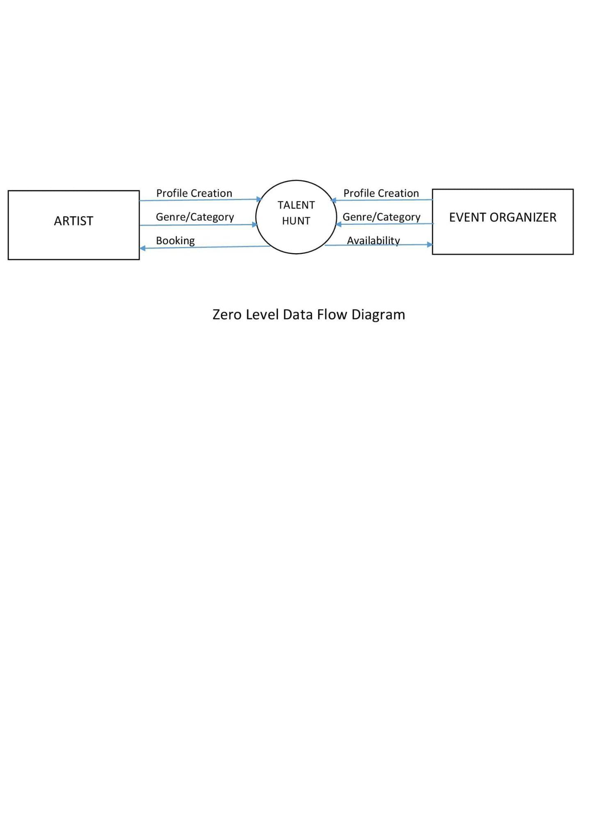





* + 1. **First Level DFD:**

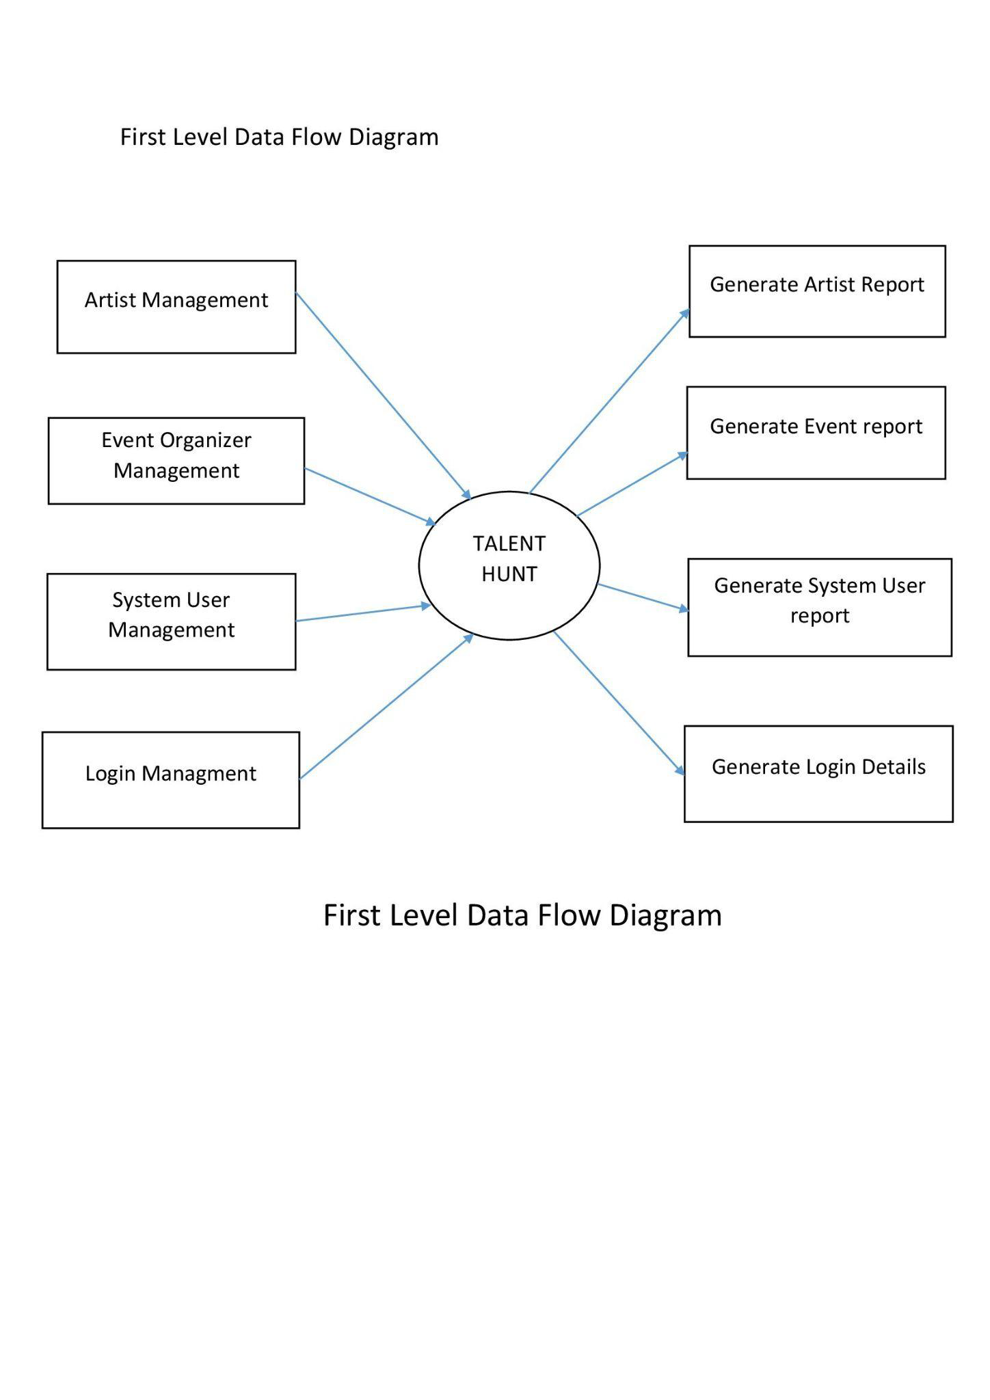





* + 1. **Second Level DFD:**

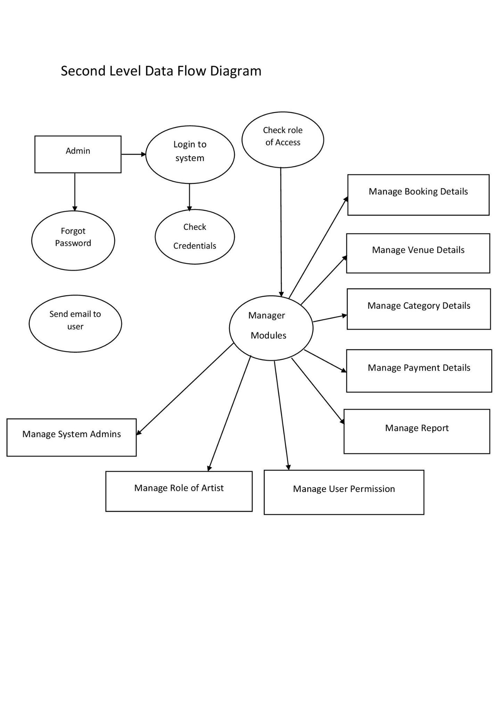



### Entity Relationship Diagram



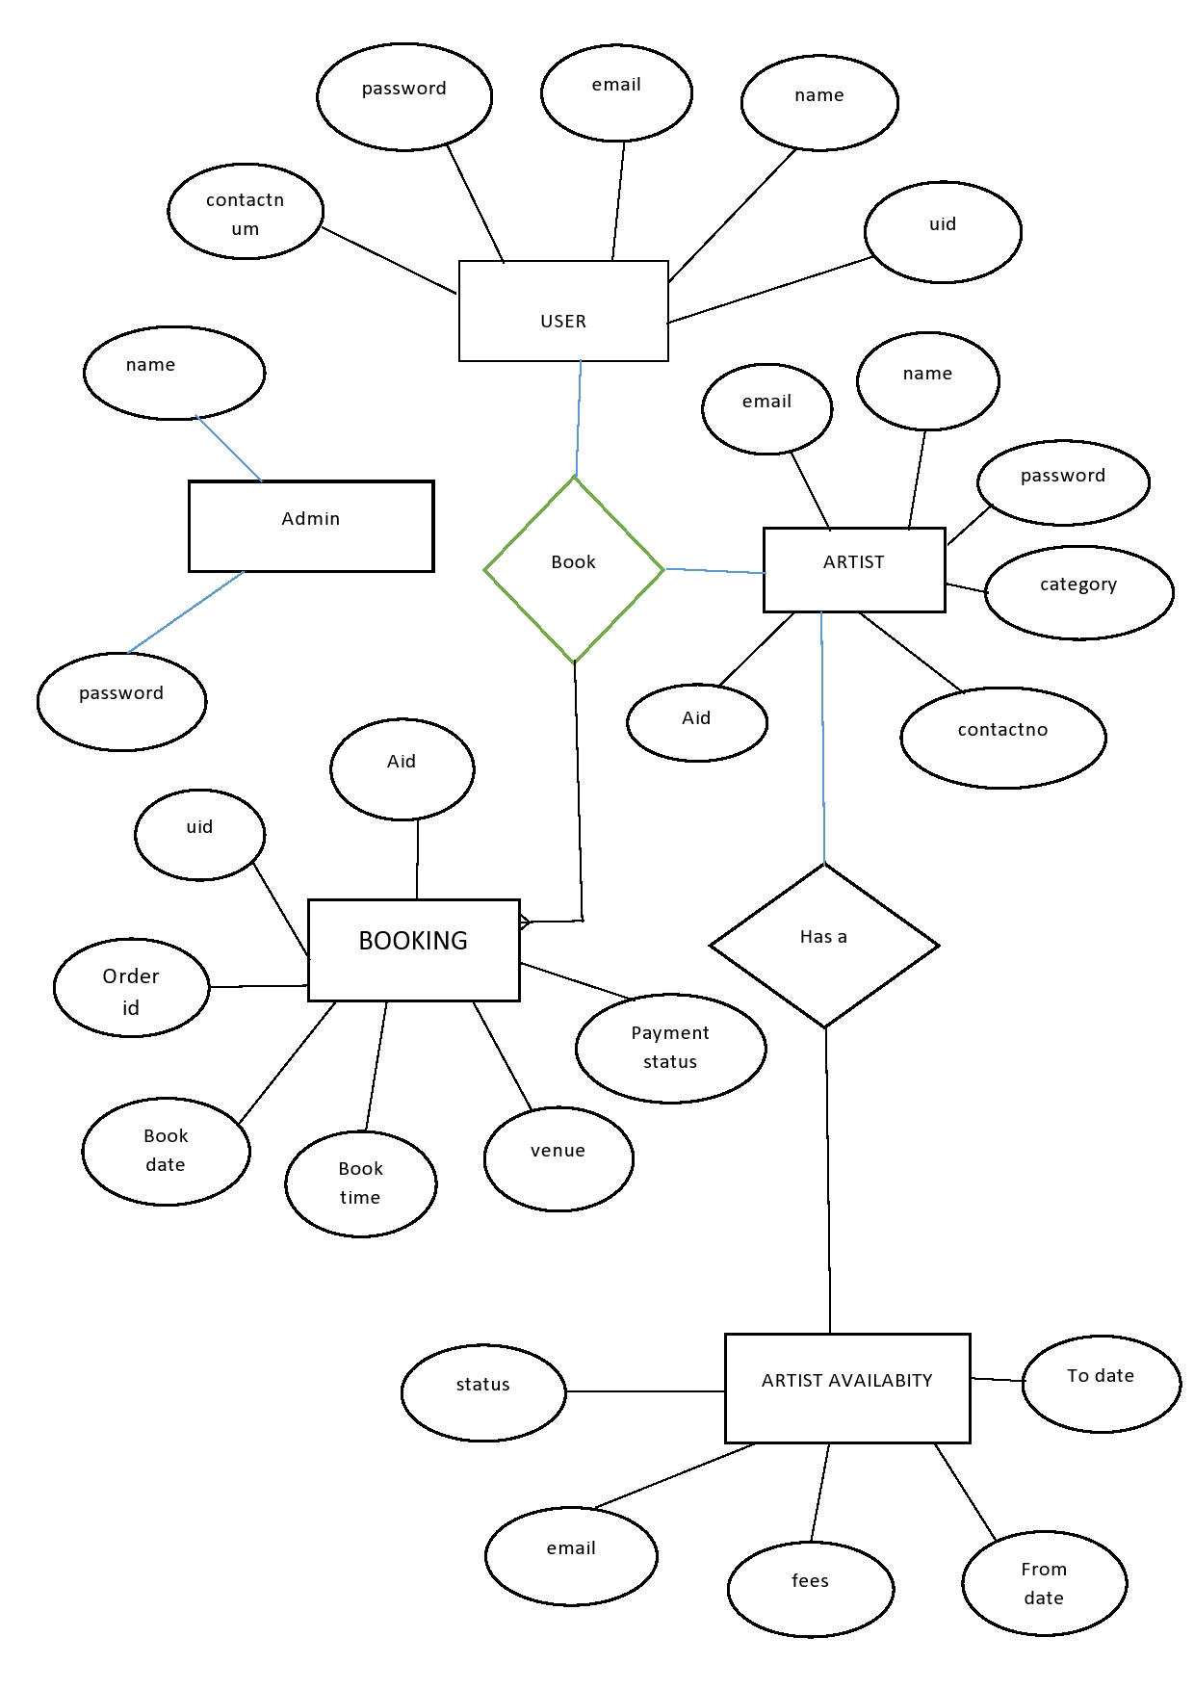





### Usecase Diagram

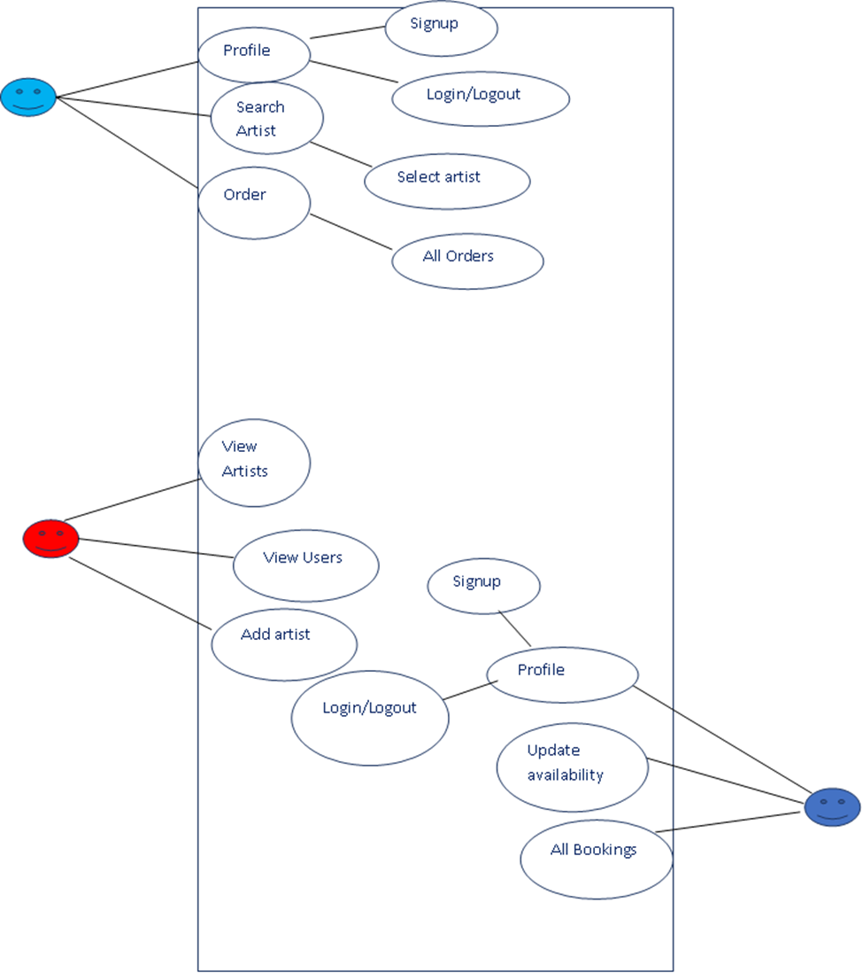





* 1. **Class Diagram**



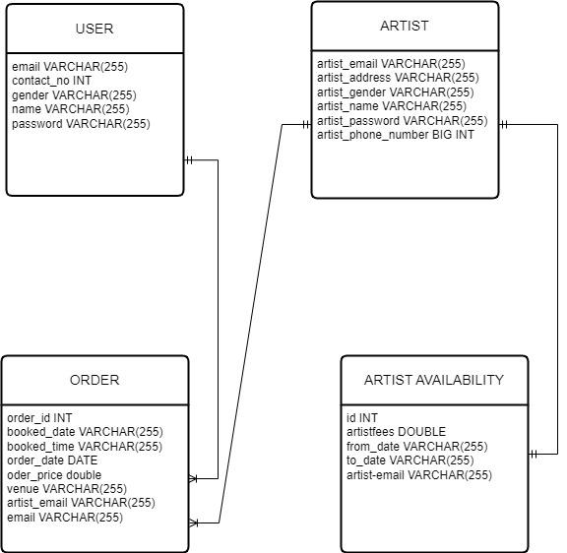



# Sequence Diagram

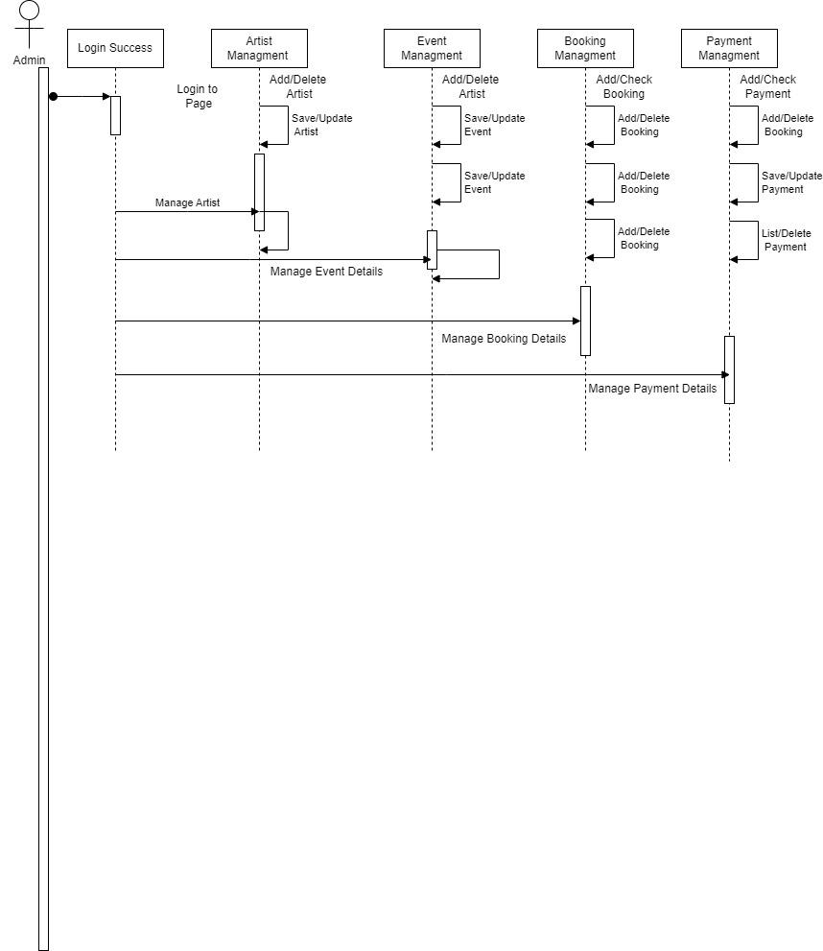







### Activity Diagram

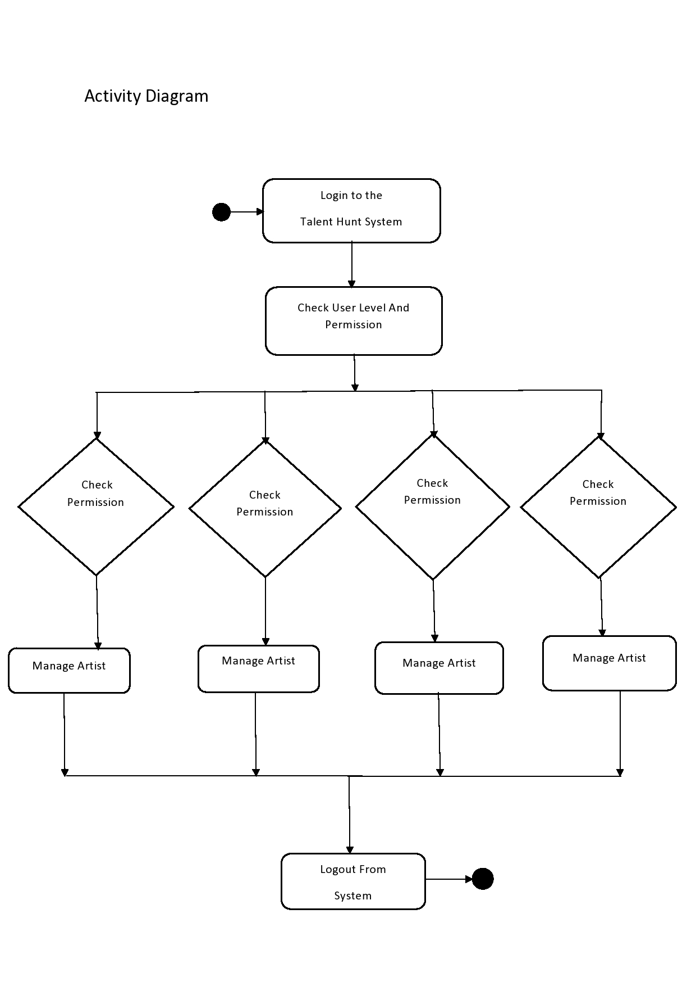





* 1. **Deployment Diagram**

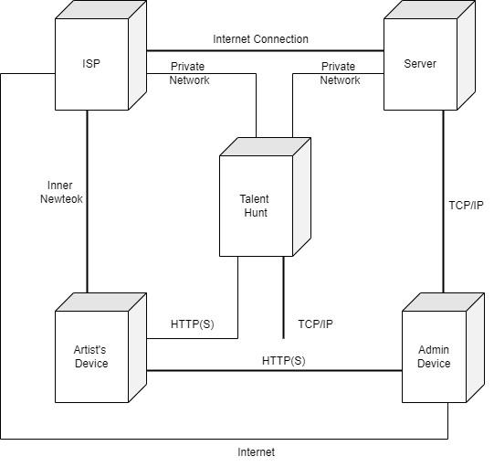





### Test Cases

| Test Case ID | Test Case | Test Case I/P | Actual Result | Expected Result | Test case criteria(P/F) |
| --- | --- | --- | --- | --- | --- |
| 001 | Admin enter the correct username or password click on submit button | Username or password | Accept | Accept | P |
| 001 | Admin enter the wrong username or password  click on submit button | Username or password | Error come | Accept | P |
| 002 | Artist enter the correct username or password click on submit button | Username or password | Accept | Accept | P |
| 002 | Artist enter the wrong username or password  click on submit button | Username or password | Error come | Accept | P |
| 003 | Event Organizer enter the correct username or password click on submit button | Username or password | Accept | Accept | P |
| 003 | Event Organizer enter the wrong username | Username or password | Error come | Accept | P |

#### Login Test Cases





**Registration Test Cases**

| Test Case ID | Test Case | Test Case I/P | Actual Result | Expected Result | Test case criteria(P/F) |
| --- | --- | --- | --- | --- | --- |
| 001 | Enter the number in username field | Number | Error Comes | Error Should Comes | P |
| 001 | Enter the character in username field | Character | Accept | Accept | p |
| 002 | Enter the invalid email id format in email id field | ppgmail,com | Error comes | Error Should Comes | P |
| 002 | Enter the valid email id format in  email id field | [pp@gmail.com](mailto:pp@gmail.com) | Accept | Accept | P |
| 003 | Enter the invalid digit no in phone no field | 99999 | Error comes | Error Should Comes | P |
| 003 | Enter the 10 digit no in phone no field | 9999999999 | Accept | Accept | P |
| 006 | Enter the 8 digit password | 44444444 | Accept | Accept | P |





#### System Test Cases

| Test Case ID | Test Case | Test Case I/P | Actual Result | Expected Result | Test case criteria(P/F) |
| --- | --- | --- | --- | --- | --- |
| 001 | Event Organizer login into the system | Username or password | Accept | Accept | P |
| 001 | Search for Artist | Display all Artist within city | Accept | Accept | P |
| 001 | Every Organizer will book the Artist | Booking redirect to payment page | Accept | Accept | P |
| 001 | Payment Page | Payment Success. | Accept | Accept | P |
| 001 | Artist login to the system | Username or password | Accept | Accept | P |
| 001 | Artist will show his details and genre into the system | Artist Details | Accept | Accept | P |
| 001 | Event Organizers can check Artist details | Artist table | Accept | Accept | P |
| 001 | Admin login into system | Username or password | Accept | Accept | P |
| 002 | Admin Dashboard | Dashboard | Accept | Accept | P |
| 002 | Admin can see users table | Users table | Accept | Accept | P |
| 003 | Admin can see listed Artist | Artist Table | Accept | Accept | P |
| 003 | Admin can see Booking table | Bookings Table | Accept | Accept | P |





**Logout Test Cases**

| Test case ID | Test case | Test case I/P | Actual Result | Expected Result | Test cases criteria(P/F) |
| --- | --- | --- | --- | --- | --- |
| 001 | Logout | User exit | Session exit | Logout successfully | P |

**GUI Testing**

| Test case | Login Screen- Sign up |
| --- | --- |
| Objective | Click on sign up button then check all required/ mandatory fields with leaving all fields blank |
| Expected Result | All required/ mandatory fields should display with symbol “*”. Instruction line “* field(s) are mandatory” should be displayed |
| Test case | Create a Password >>Text Box Confirm Password >>Text Box |
| Objective | Check the validation message for Password and Confirm Password field |
| Expected Result | Correct validation message should be displayed accordingly or “Password and confirm password should be same” in place of “Password mismatch”. |





# Screenshots

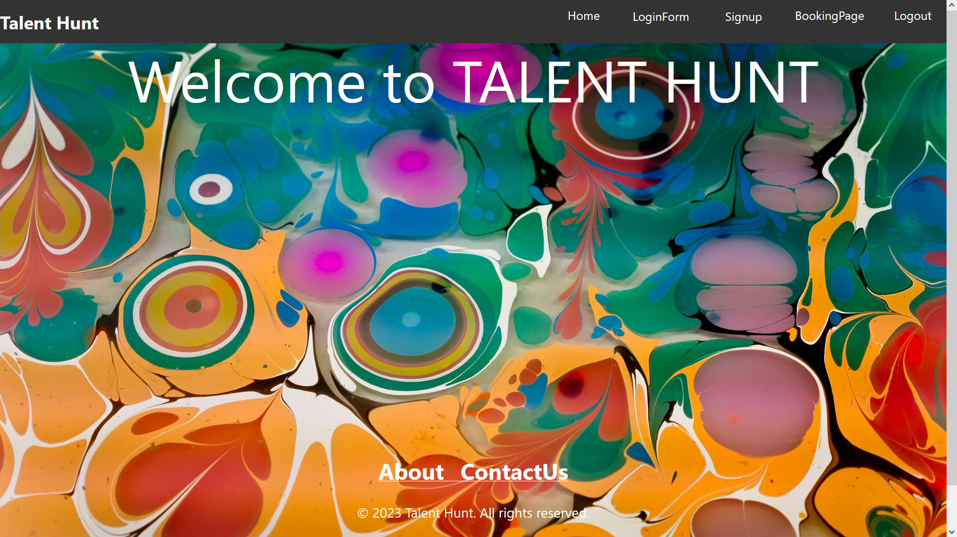

**Home Page-1**

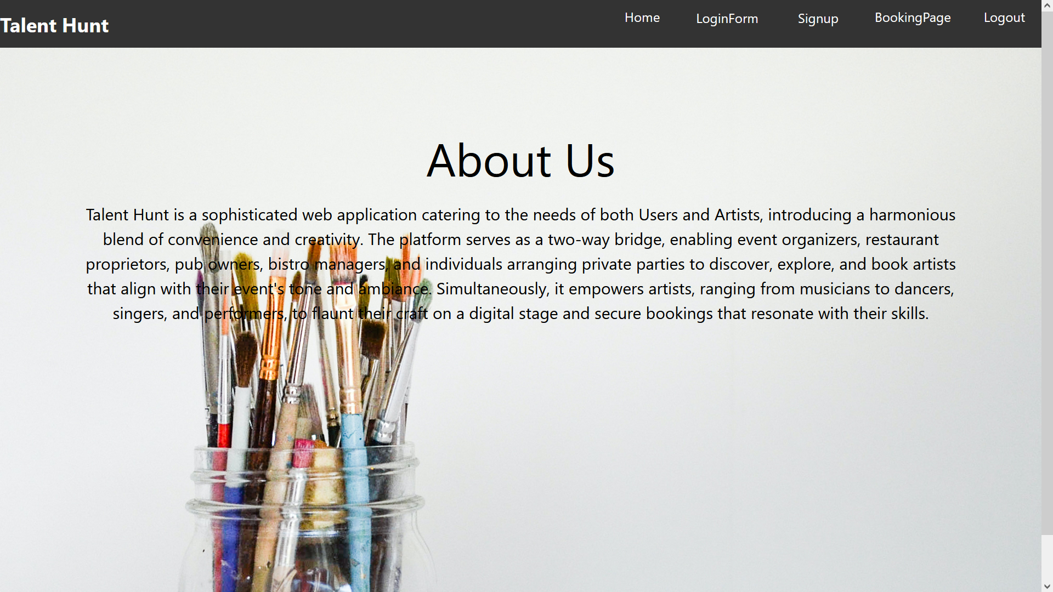

**Home Page-2**





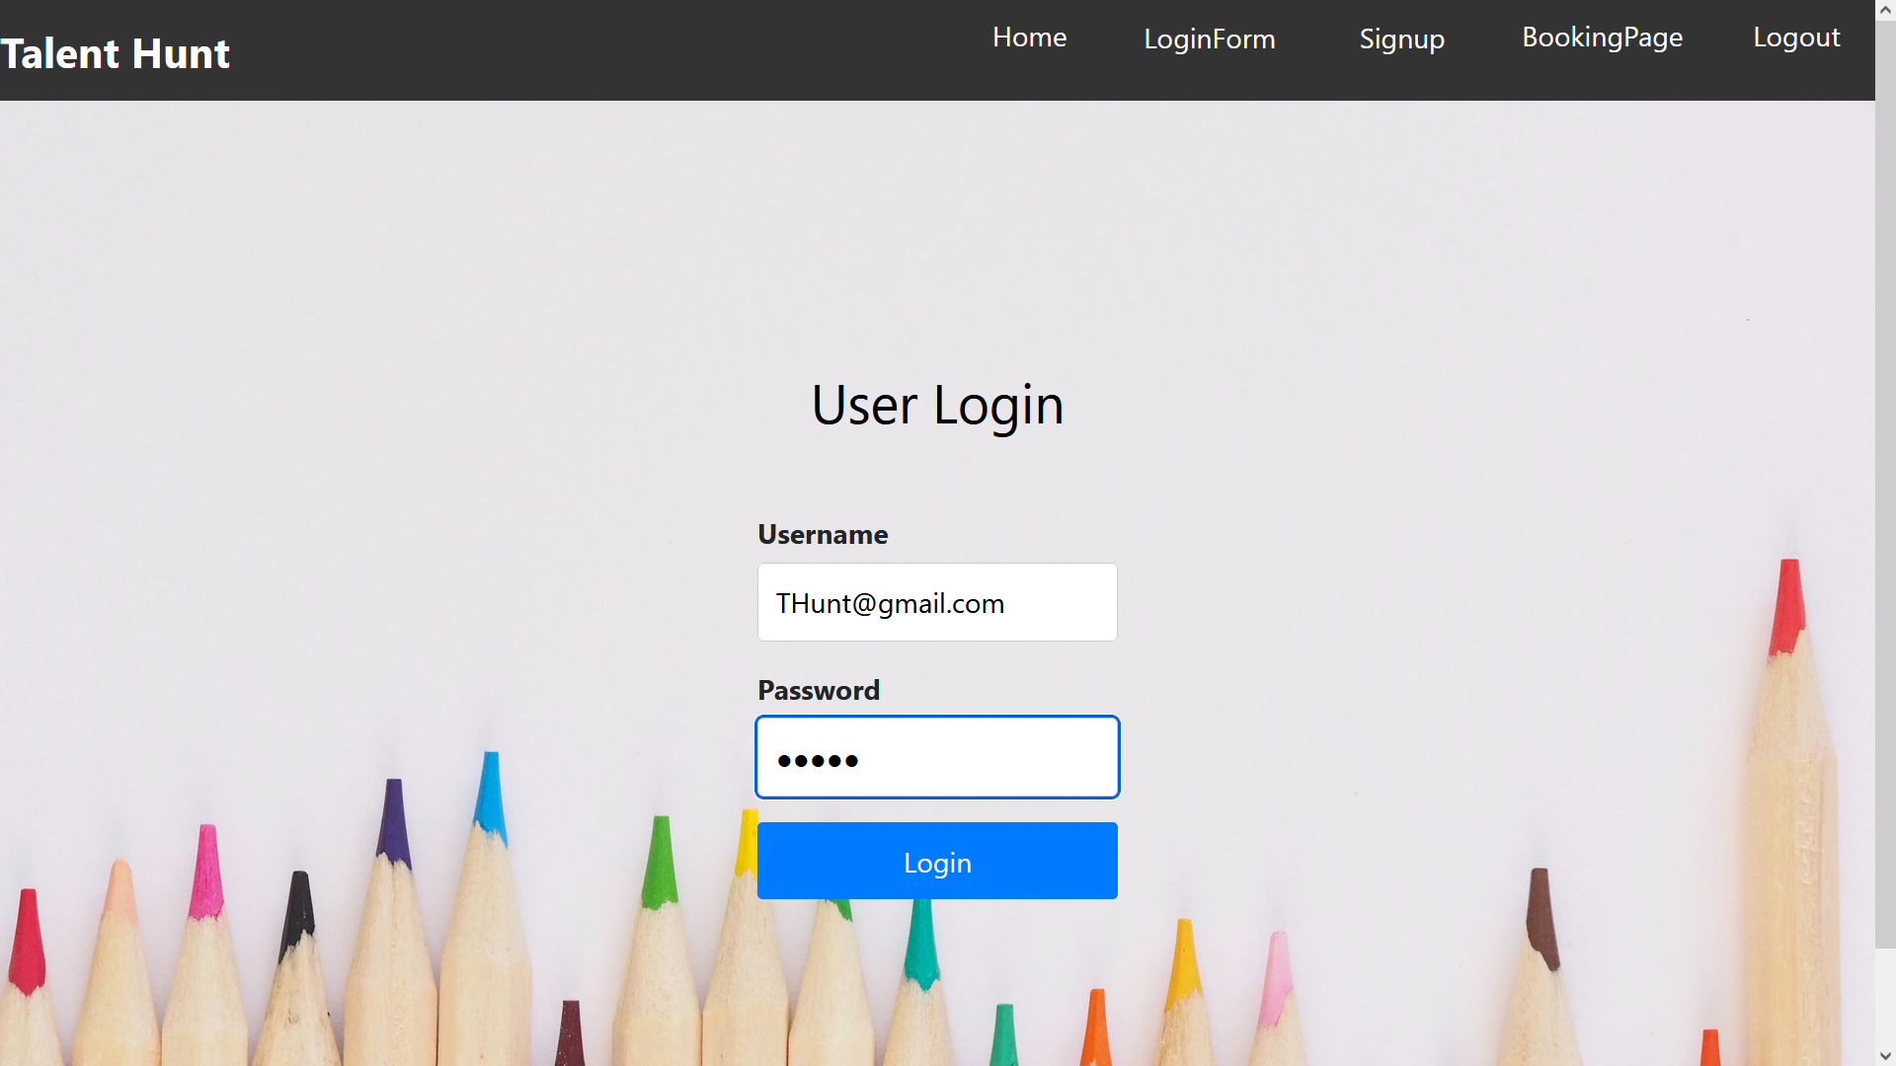

**Sign-In page**

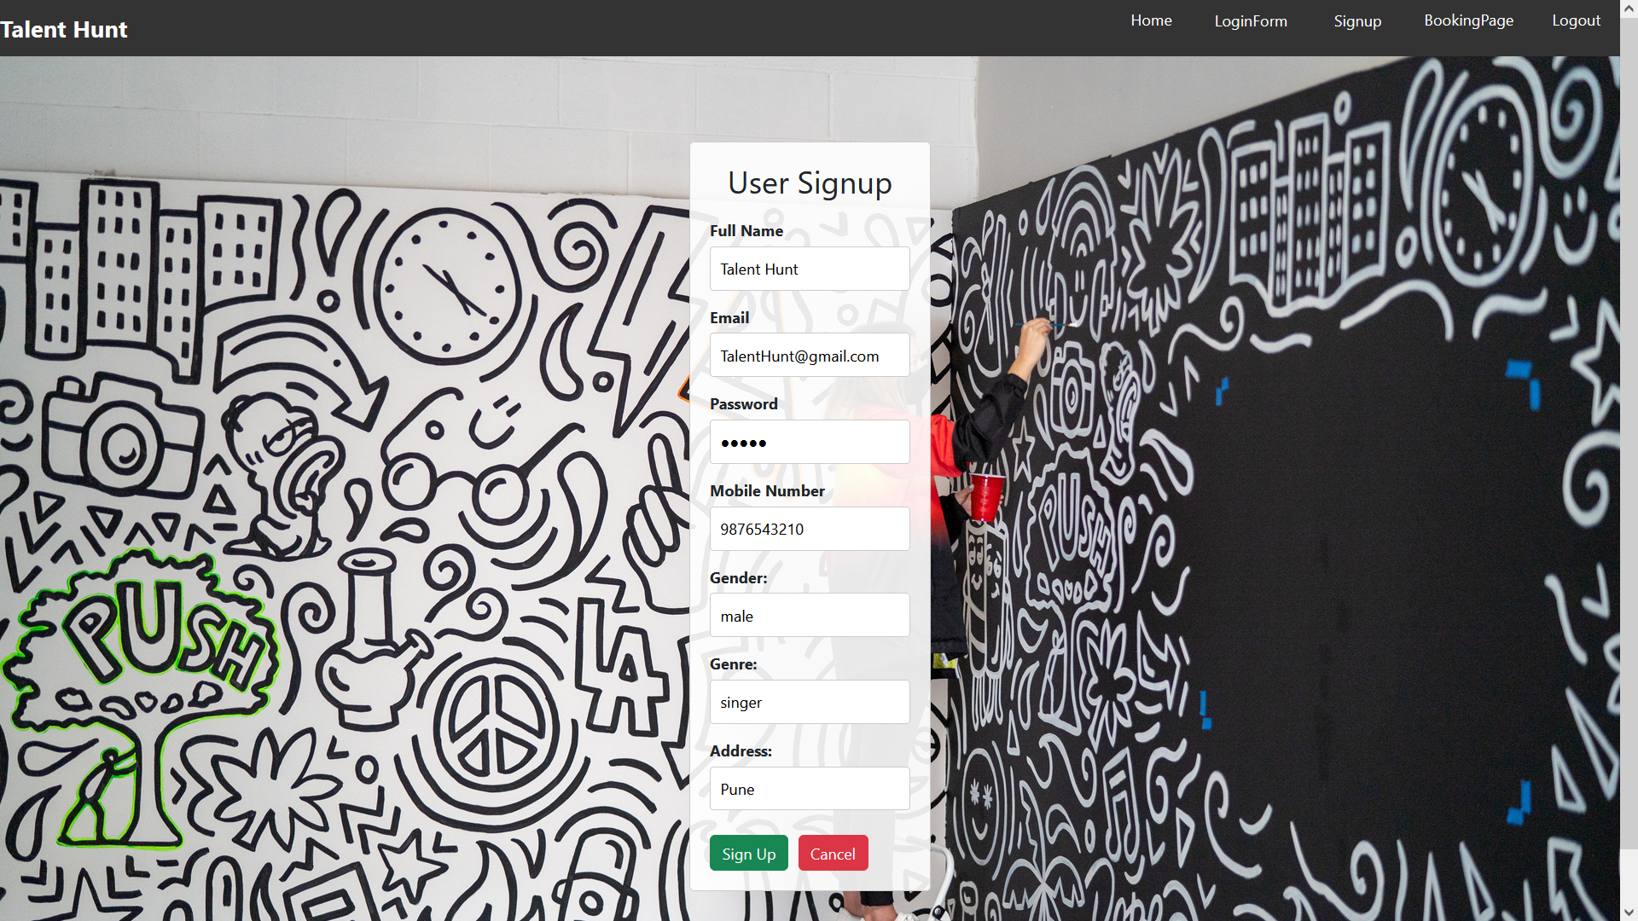

**Sign-Up page**





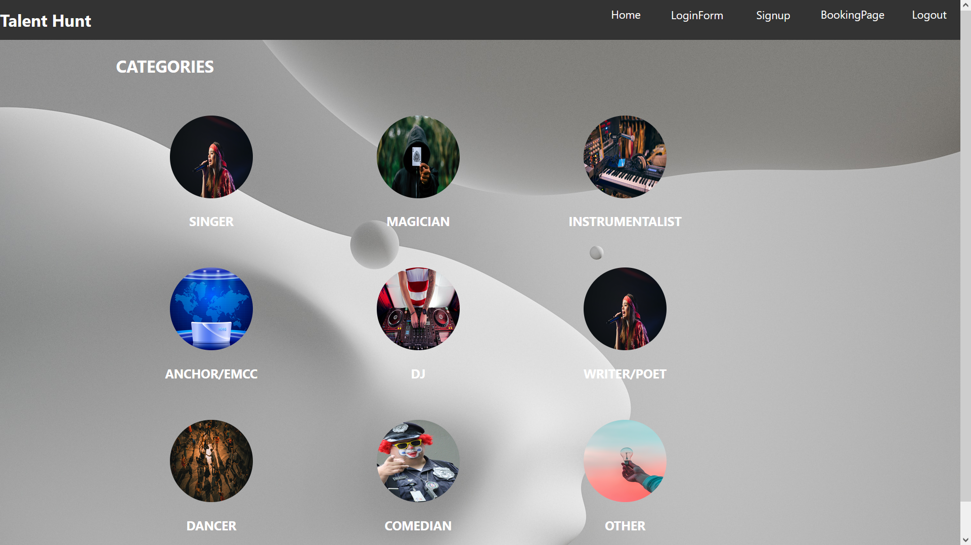

**Categories**

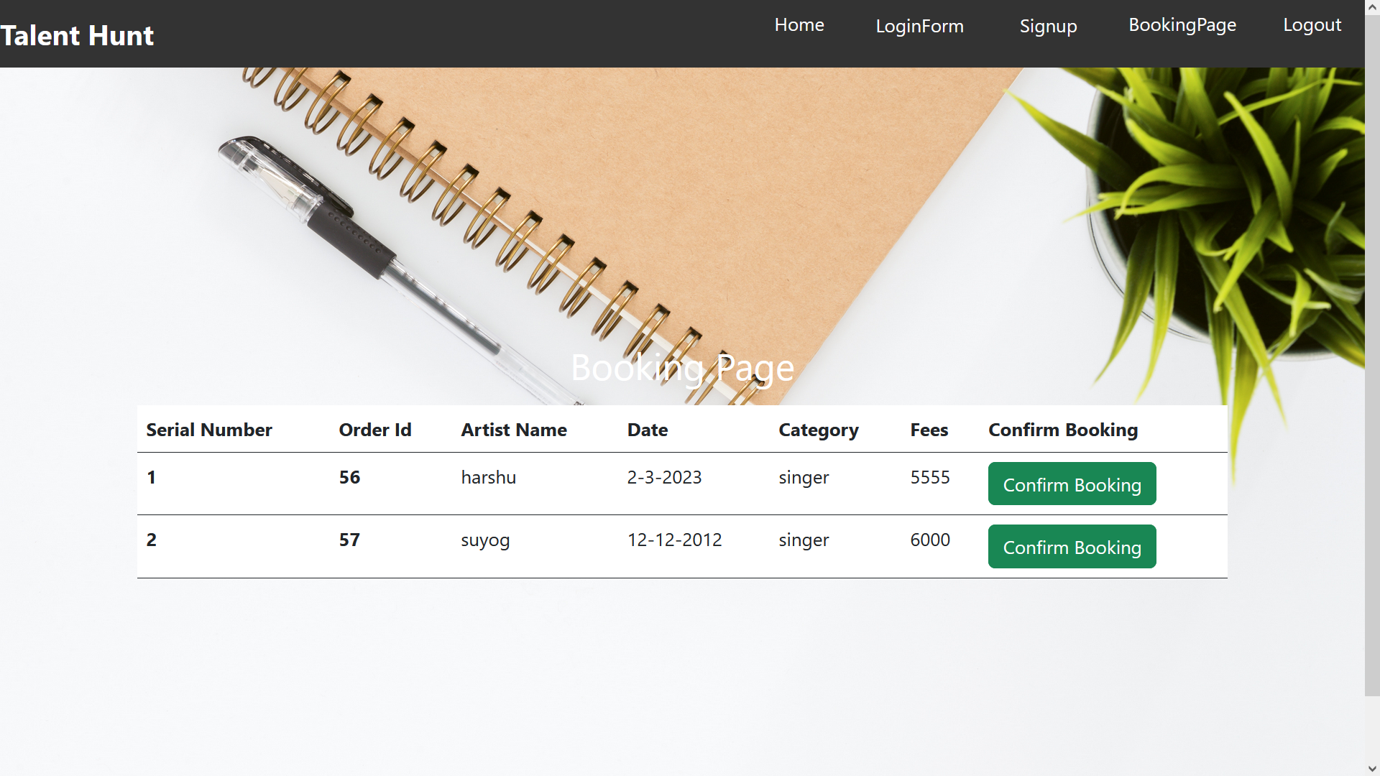

**Booking Page**





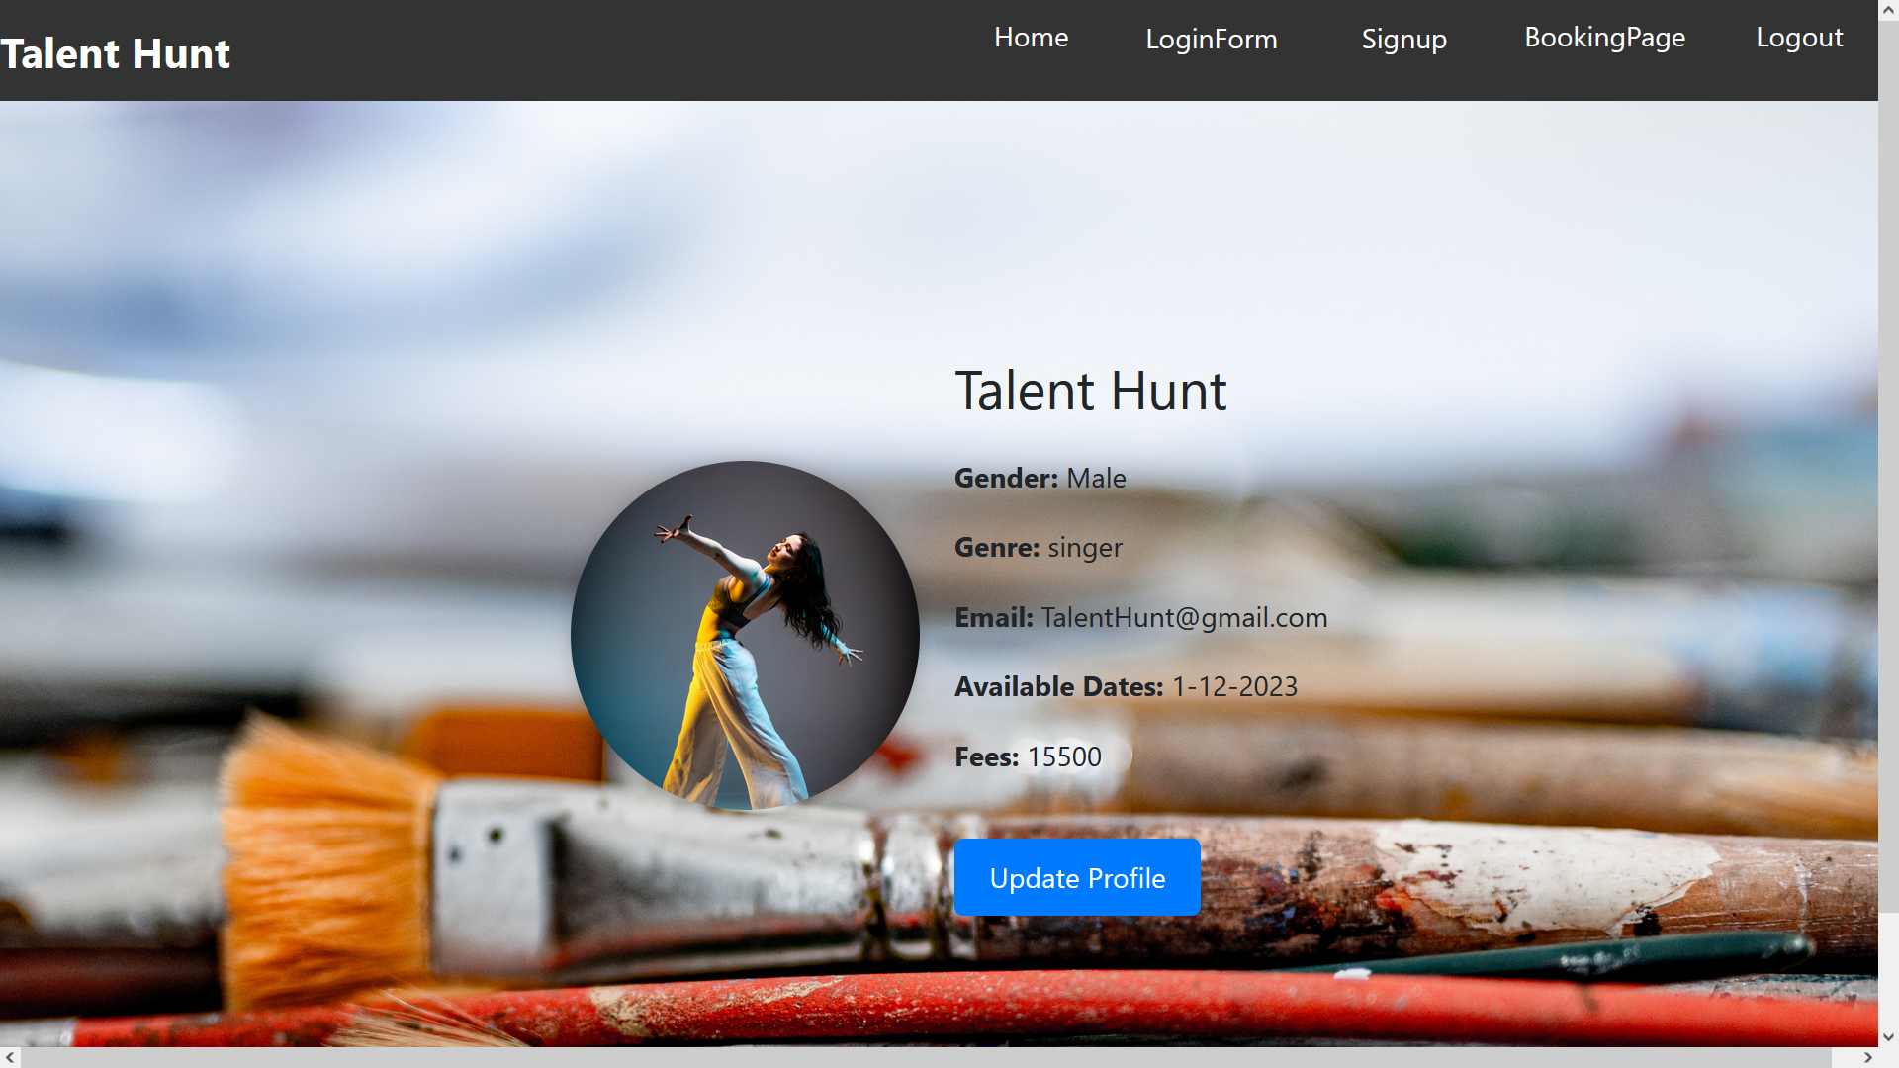

**Profile Page**

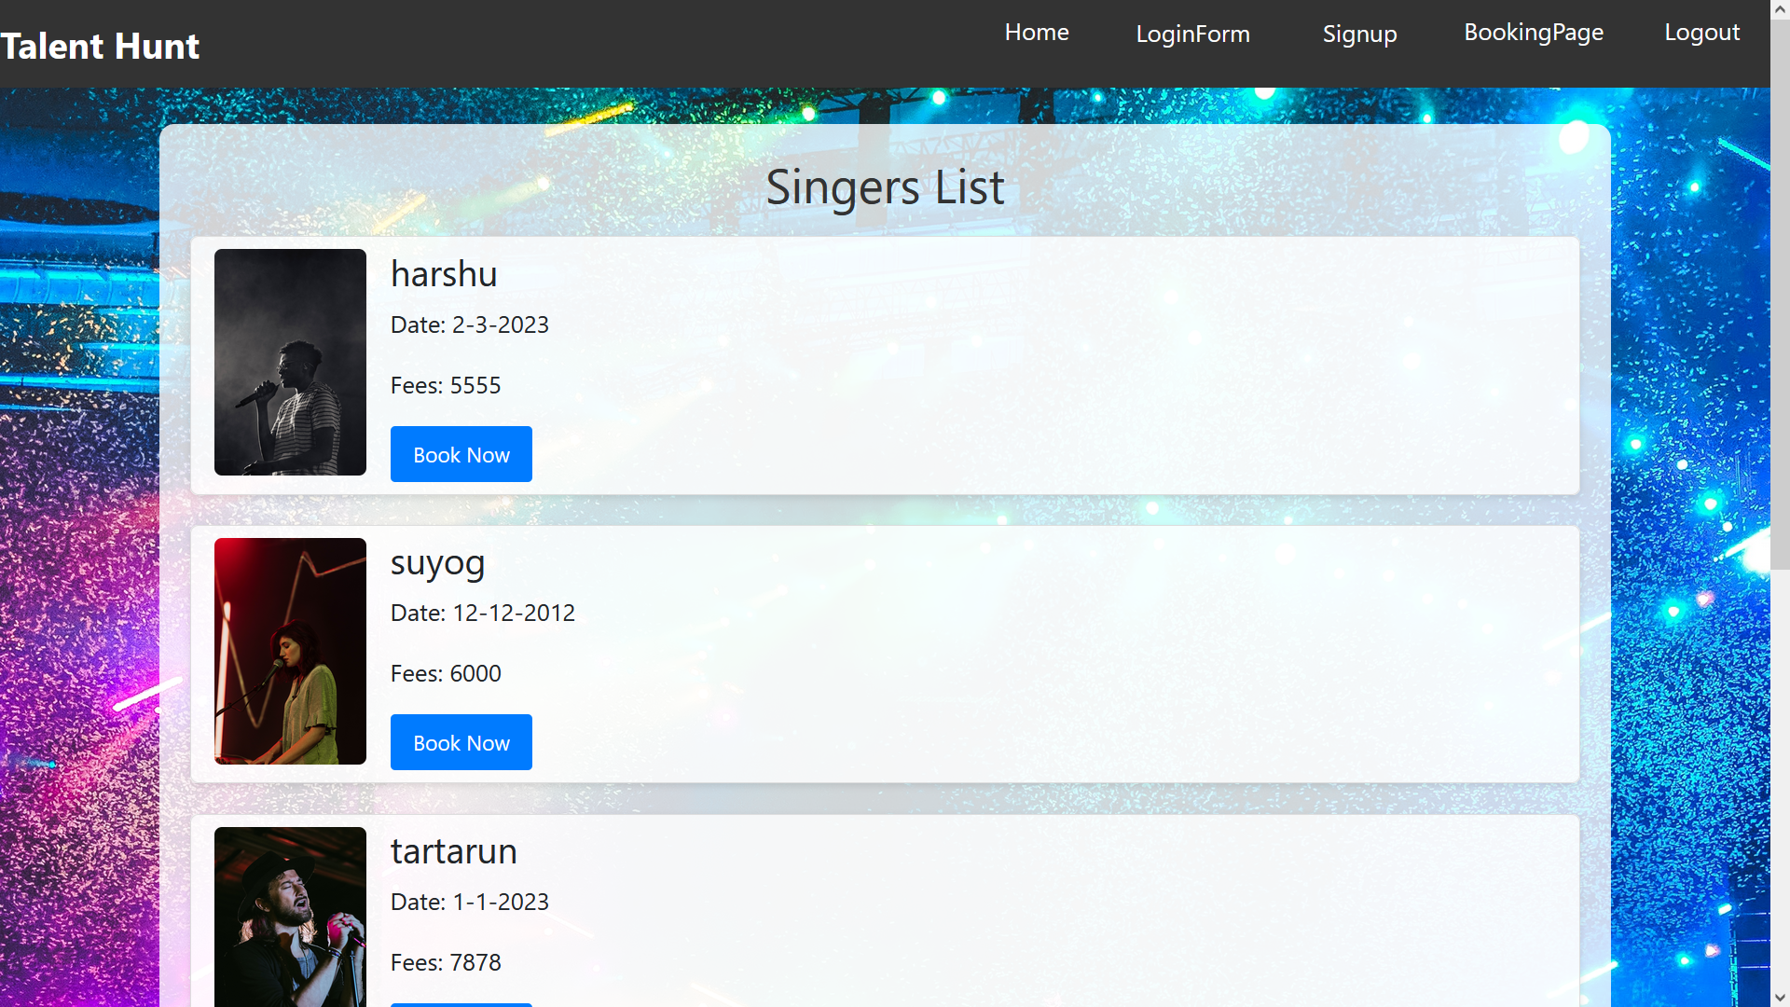

**Selected Artist List**





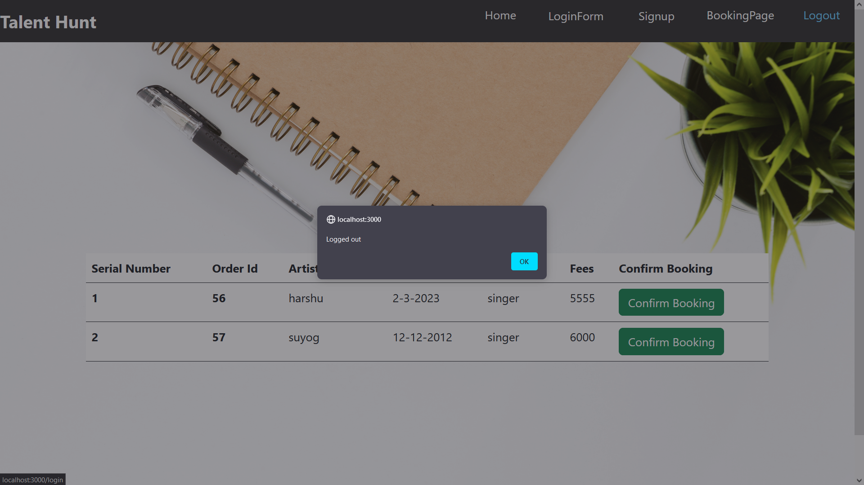

**Logout Page**

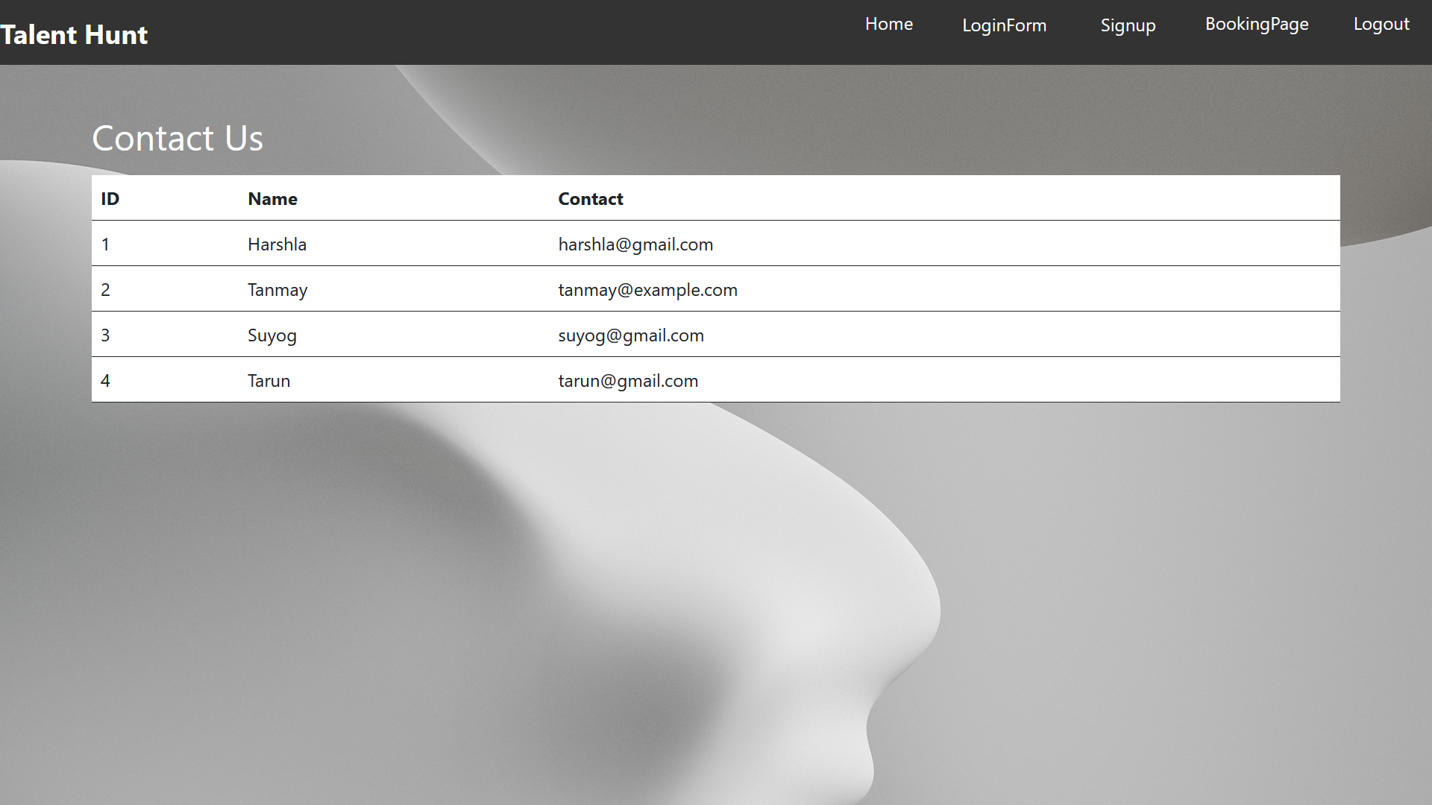

**Contact Us Page**





# References

1. Zhang, J., & Zhang, L. (2020). An Online Booking System for Arts Performances in Rural China. In Proceedings of the 2nd International Conference on Computer Science and Application Engineering (pp. 33-37).

2. Pressman, R. S. (2014). Software Engineering: A Practitioner's Approach (8th ed.). McGraw-Hill Education.

3. Sommerville, I. (2016). Software Engineering (10th ed.). Pearson.

4. Ambler, S. W. (2002). Agile Modeling: Effective Practices for Extreme Programming and the Unified Process. John Wiley & Sons.

5. Larman, C. (2004). Applying UML and Patterns: An Introduction to Object-Oriented Analysis and Design and Iterative Development (3rd ed.). Pearson.

6. Booch, G., Rumbaugh, J., & Jacobson, I. (2005). The Unified Modeling Language User Guide (2nd ed.). Addison-Wesley.

7. Oracle Corporation. (n.d.). MySQL. Retrieved from https://www.mysql.com/

8. Spring Boot Documentation. (n.d.). Retrieved from https://spring.io/projects/spring-boot

9. React Documentation. (n.d.). Retrieved from https://reactjs.org/docs/getting-started.html

10. Rozanski, N., & Woods, E. (2011). Software Systems Architecture: Working with Stakeholders Using Viewpoints and Perspectives. Addison-Wesley.

11. Bass, L., Clements, P., & Kazman, R. (2012). Software Architecture in Practice (3rd ed.). Addison-Wesley.

12. Fowler, M. (2002). Patterns of Enterprise Application Architecture. Addison-Wesley.

13. Gamma, E., Helm, R., Johnson, R., & Vlissides, J. (1994). Design Patterns: Elements of Reusable Object-Oriented Software. Addison-Wesley.

14. Brown, A. W., & Wallnau, K. C. (2013). Antipatterns: Identification, Refactoring, and Management. CRC Press.

15. Newman, S. (2015). Building Microservices: Designing Fine-Grained Systems. O'Reilly Media.

16. Gamma, E. (1995). The State Pattern. Design Patterns: Elements of Reusable Object-Oriented Software.

17. Osterwalder, A., & Pigneur, Y. (2010). Business Model Generation: A Handbook for Visionaries, Game Changers, and Challengers. John Wiley & Sons.

18. Cusumano, M. A. (2010). Staying Power: Six Enduring Principles for Managing Strategy and Innovation in an Uncertain World. Oxford University Press.

